'''

Mr. Kejriwal purchased a digital clock, it shows the time in "hh:mm" 24 hr format.

Due to technical issue, in the place of some digits ot displays '#' symbol.

As Mr Kejriwal is an IIT student also, he got an idea to find the number of

valid times by replacing '#' with valid digits between 0-9.

You are iven the time as a string T.

Your task is to help Mr Kejriwal to find the number of possible valid times.

NOTE:

-----

The valid time is in the range of 00:00 to 23:59.

Input Format:

-------------

A string T, the time in the (24-hr) format as "hh:mm"

Output Format:

--------------

Print an integer result.

Sample Input-1:

---------------

#6:00

Sample Output-1:

----------------

2

Explanation:

------------

The valid times after replacing # with 0 or 1, are "06:00", "16:00".

Sample Input-2:

---------------

0#:0#

Sample Output-2:

----------------

100

Explanation:

------------

To make the given time valid, replace 1st # with 0-9 digits and 2nd with the same.

So, totally we have 100 ways.

Write your python code below

'''

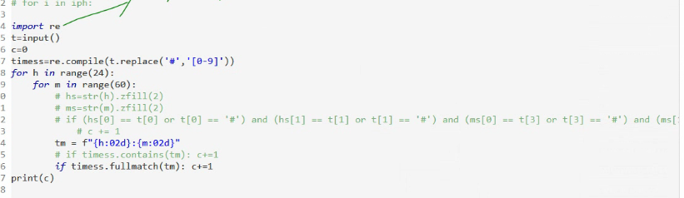

In a theatre, there are N people stand in a line for tickets,

male represented with 1 and female represented with 0.

Theater management decides to issue the tickets in such a way that

if one ticket issued to a male, next ticket should be issued to a female only,

and vice versa.

In order to follow it, they planned to make few alterations in the line itself,

so that no two adjacent persons have same gender.

You are given a binary string S, represents intial order of the people in the line.

In one alteration, you can replace one female '0' with a male '1' or vice versa.

Your task to find and print the minimum number of alterations needed

to make the line to follow alternate gender sequence.

Input Format:

-------------

A binary String, S.

Output Format:

--------------

Print an integer, minimum number of alterations.

Sample Input-1:

---------------

1001

Sample Output-1:

----------------

2

Sample Input-2:

---------------

101101

Sample Output-2:

----------------

3

